Secure Information Exchange
Program
· · ·
a simulation in
DIFFIE–HELLMAN KEY EXCHANGE
with
AES–128 BLOCK ENCRYPTION

submitted by
violdan e. bayocot

§ I
Project Overview
· · ·
This document accompanies a Windows Forms implementation of the Secure Information Exchange Program, a simulation in which two parties—User A and User B—agree on a shared secret over an untrusted channel and use that secret to encrypt and decrypt a plaintext message. The protocol combines a classical Diffie–Hellman key exchange with symmetric AES-128 block encryption.
The implementation follows the specification closely: the public parameters are the prime p = 199 and the generator g = 127; private keys are interpreted as the decimal equivalents of ASCII characters; the computed shared key is transformed into a 128-bit AES key by a deterministic rule based on its digit count; and the plaintext is segmented into sixteen-character blocks padded with the character ‘@’ where necessary. Each block is encrypted independently in ECB mode and concatenated to form the ciphertext transmitted to the receiver.
§ II
Repository
· · ·
The full source code, organized into the seven commits described in the build journal, is available at the public Git repository below. Each commit leaves the project in a working state and corresponds to one self-contained stage of the implementation.

GitHub Repository
https://github.com/decr0zeath/bayocot-secure-software

§ III
Verification Against the Specification
· · ·
The following test vector, drawn directly from the original specification, exercises every stage of the program. When executed, the implementation must reproduce each of the values below exactly. The screenshots that follow this section provide visual confirmation.
The values listed below are the inputs to the simulation.
Parameter | Value
Private Key of User A | 57
Private Key of User B | 167
Prime p | 199
Generator g | 127

Plaintext message: "The Mandalorian Must Always Recite, This is The Way!"
Running the simulation must reproduce exactly the values below.
Computed Quantity | Expected Value
Public Value of User A (g^a mod p) | 17
Public Value of User B (g^b mod p) | 75
Shared Key from User A (B^a mod p) | 109
Shared Key from User B (A^b mod p) | 109
AES-128 Key (ASCII) | 109F109F109F109F

The plaintext is segmented into four 16-character sub-messages:
[1] "The Mandalorian "
[2] "Must Always Reci"
[3] "te, This is The "
[4] "Way!@@@@@@@@@@@@" ← padded with '@'
Block four is shorter than sixteen characters in the original message and is therefore right-padded with the character ‘@’ (binary 01000000) until it reaches the full 128-bit block length, as required by the specification.

§ IV
Walkthrough
· · ·
The four screenshots below trace a single complete run of the simulation, from an empty form through key derivation, encryption, and finally decryption on the receiver’s side. Each figure should match the corresponding row of the test vector in Section III.

Step 1 · Initial State
The application has just been launched; no fields have been populated.
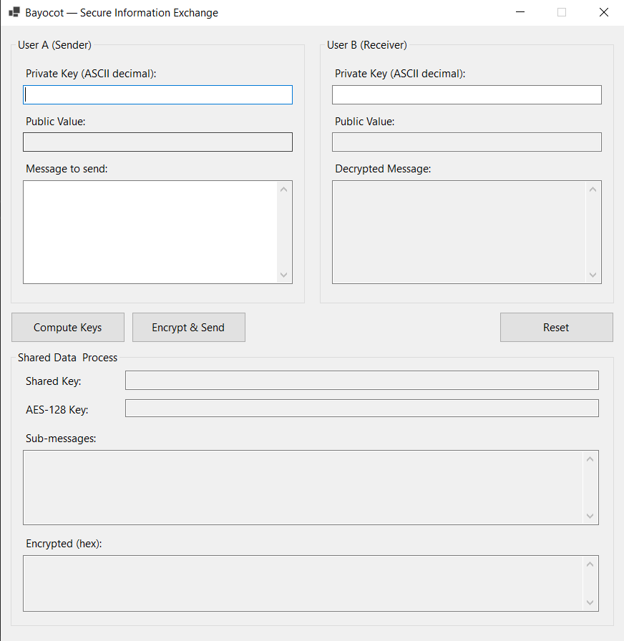
Figure 1. The application on first launch, before any input is entered.
Step 2 · Key Derivation
After entering the two private keys and pressing Compute Keys, the public values are displayed for both users, the shared key is computed independently from each side (both must equal 109), and the 128-bit AES key is shown as 109F109F109F109F.
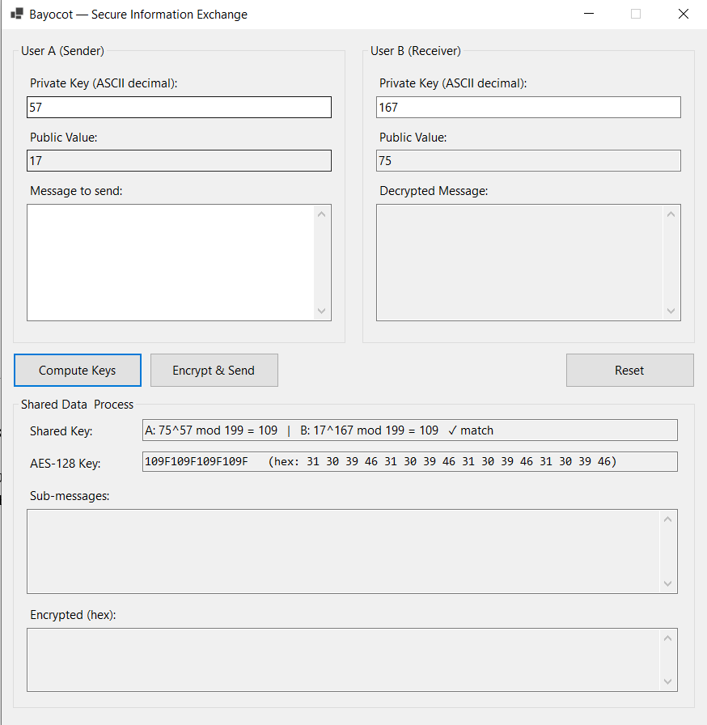
Figure 2. Public values, shared key (109), and the derived AES-128 key 109F109F109F109F.

Step 3 · Encryption and Transmission
Entering the plaintext message and pressing Encrypt & Send produces the four sub-messages listed in Section III, with the fourth padded by twelve ‘@’ characters. Each block is encrypted independently with AES-128 and the four ciphertext blocks are concatenated for transmission.
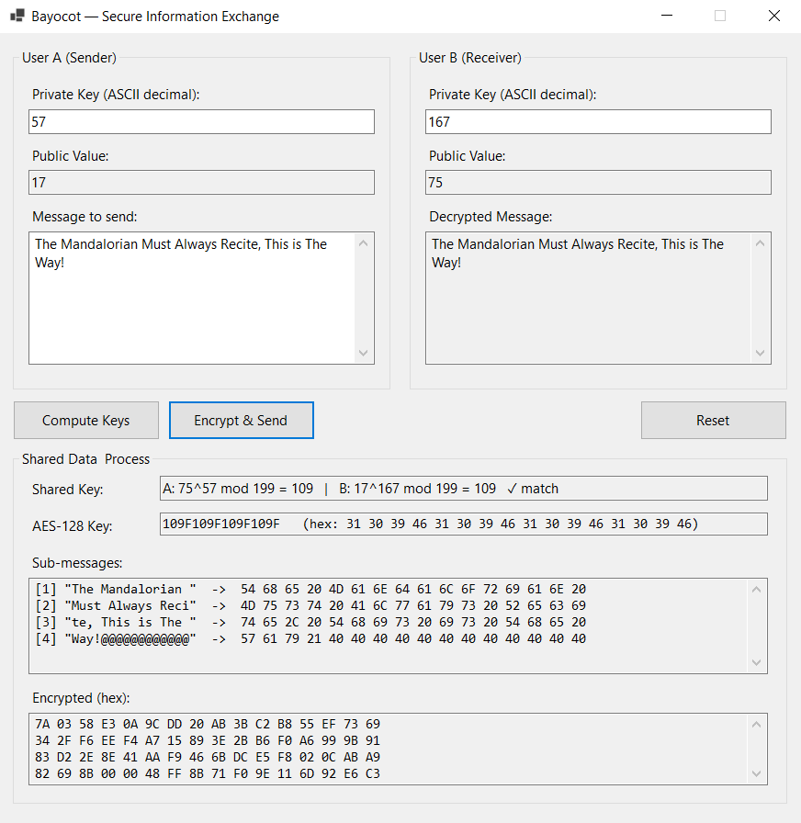
Figure 3. The four sub-messages and the concatenated AES-128 ciphertext in hexadecimal.
Step 4 · Decryption at the Receiver
On the receiver side the shared key is re-derived independently from User B’s private key and User A’s public value, the ciphertext is split back into 16-byte blocks, each block is decrypted, and the trailing ‘@’ padding is removed to recover the original plaintext.

Figure 4. The receiver pane displays the recovered plaintext, matching the original message exactly.

§ V
Conclusion
· · ·
The implementation reproduces every value specified in the original document: the public values 17 and 75, the shared key 109 derived independently by both parties, the AES-128 key 109F109F109F109F, the four 16-character sub-messages including the ‘@’-padded final block, and—after a complete encrypt– decrypt cycle—the original plaintext message. The simulation thus demonstrates, end to end, the use of Diffie–Hellman to establish a symmetric key over an untrusted channel and the subsequent use of that key with AES-128 to protect the confidentiality of a transmitted message.

· · · · ·
end of document

